STUDENT CASE STUDY EXECUTION REPORT
Department | FED
Subject | DSA-2
Academic Year | I-III Semester (2025-26)
Faculty Name | ____________________
Student Name | ____________________
Roll Number | ____________________
Branch | CSE (AI & DS)
Course Outcome | Apply graph algorithms and Union-Find techniques for solving real-world network optimization problems.

Work Done Summary
In this case study, we analyzed a GitHub Actions workflow dependency graph to detect cyclic dependencies between jobs using Depth First Search (DFS).
The work focused on:
- Representing workflow jobs as vertices in a directed graph.
- Representing job dependencies as directed edges.
- Applying DFS traversal for cycle detection.
- Using WHITE, GREY, and BLACK vertex coloring technique.
- Identifying the exact edge responsible for the cycle.
- Detecting the cyclic dependency between:
  - build → test → integration → build
- Analyzing the time complexity of DFS-based cycle detection.

Implementation Details
- Modeled GitHub workflow jobs as directed graph nodes.
- Represented dependency relationships using adjacency lists.
- Initialized all vertices with WHITE color (unvisited).
- During DFS traversal:
  - WHITE → currently unvisited
  - GREY → currently in recursion stack
  - BLACK → fully processed
- Started DFS traversal from the build job.
- Traversed jobs in alphabetical neighbor order.
- Marked a node GREY when DFS entered it.
- Marked a node BLACK after all neighbors were processed.
- Detected a cycle when DFS encountered a GREY node again.
- Identified the back edge:
integration → build
- Reported the cycle immediately before further traversal.
- Calculated DFS complexity for directed graph traversal.
RESULTS:SCREENSHOTS/Output:
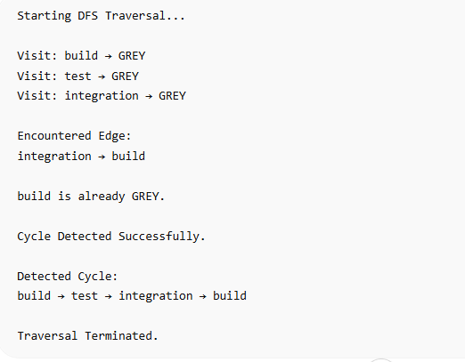

Conclusion
In this case study, DFS-based cycle detection was used because it efficiently identifies cyclic dependencies in directed graphs such as GitHub Actions workflows.
The WHITE-GREY-BLACK coloring method helped track traversal states and detect back edges accurately. A cycle was detected when the DFS traversal encountered the GREY-colored build node again through the edge integration → build.
This approach is highly efficient for CI/CD systems because workflow validation can be completed in milliseconds before actual job execution, preventing invalid deployments and dependency deadlocks.
Github Link: https://github.com/ampssubrahmanyasreepad-svg/DSA-CaseStudies
